Improvement Activity: Use of QCDR data for ongoing practice assessment and improvements (IA_PSPA_7)
Activity Weighting: Medium
Description: Use of QCDR data for ongoing practice assessment and improvements in patient safety.

Eligible clinician name:

NPI / Tax ID:

As the above-named MIPS eligible clinician, I attest that I was actively engaged with a qualified clinical data registry specific to the practice of optometry, AOA MORE (Measures and Outcomes Registry for Eyecare), for at least 90 days during the performance year.

During this time, I regularly used the registry to study the demographic distribution of my patient base (gender, age, race, ethnicity), the most common diagnoses in my practice, the most commonly prescribed medications and other data beneficial to the assessment of my practice. Examples of the data available through the AOA MORE dashboard are below:

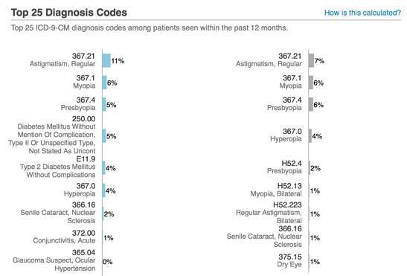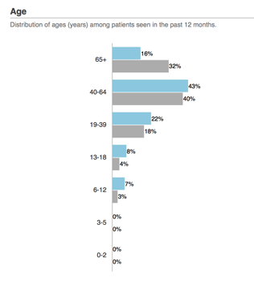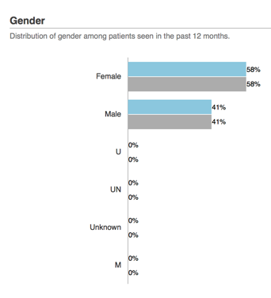
Additionally, a clinical quality measure in the Patient Safety domain is readily available within the registry allowing me to track my performance relative to my peers and make improvements, as needed.

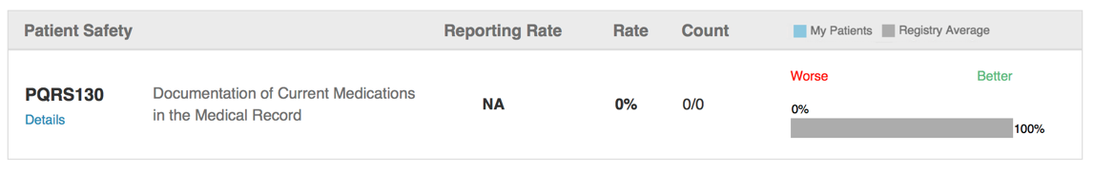

Activity Start / End Date:

