Improvement Activity: Use of QCDR for quality improvement such as comparative analysis reports across patient populations (IA_PM_10)
Activity Weighting: Medium
Description: Participation in a QCDR, clinical data registries, or other registries run by other government agencies such as FDA, or private entities such as a hospital or medical or surgical society. Activity must include use of QCDR data for quality improvement (e.g., comparative analysis across specific patient populations for adverse outcomes after an outpatient surgical procedure and corrective steps to address adverse outcome).

Eligible clinician name:

NPI / Tax ID:

As the above-named MIPS eligible clinician, I attest that I was actively engaged with a qualified clinical data registry specific to the practice of optometry, AOA MORE (Measures and Outcomes Registry for Eyecare), for at least 90 days during the performance year.

During this time, I regularly used the registry to study the demographic distribution of my patient base (gender, age, race, ethnicity), the most common diagnoses in my practice, the prevalence of glaucoma and other factors beneficial to the quality of care I provide. Examples of the data available through the AOA MORE dashboard are below:

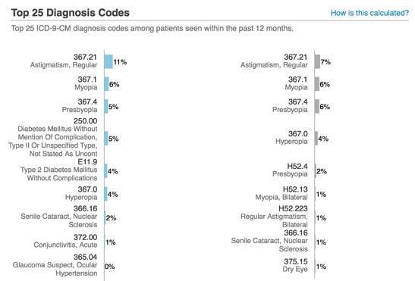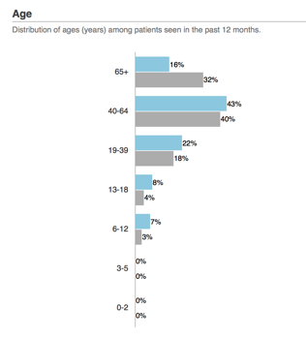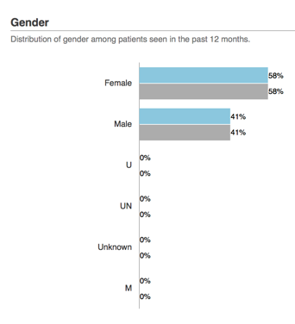

The registry also tracks and displays my statistical performance in outcome and process-based clinical quality measures. Through regular review of this information I can determine performance relative to peers / benchmarks and modify my workflow as needed. This improves the quality of care that I provide.

Activity Start / End Date:

