Improvement Activity: Implementation of use of specialist reports back to the referring clinician or group to close referral loop (IA_CC_1)
Activity Weighting: Medium
Description: Performance of regular practices that include providing specialist reports back to the referring MIPS eligible clinician or group to close the referral loop or where the referring MIPS eligible clinician or group initiates regular inquiries to specialist for specialist reports which could be documented or noted in the certified EHR technology.

Eligible clinician name:

NPI / Tax ID:

As the above-named MIPS eligible clinician, I attest that I implemented a policy to identify and close referral loops. In the case of outbound referrals where I have made a request for consultation, we regularly perform a search in our CEHRT to identify patients for whom we have not yet received a summary report from the consulting clinician. That information is then used to facilitate outreach to the consultant where required. Below is our search criteria which we customize based on desired period of time:
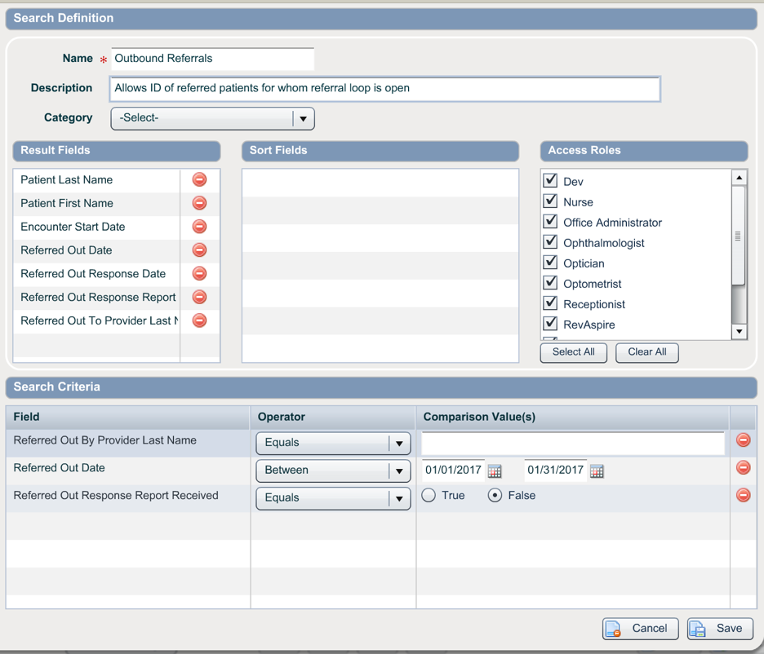
For inbound referrals, our certified EHR technology can produce a summary report at the conclusion of the encounter incorporating my exam findings and recommendations. This document can be provided to the referring provider.

Through the above procedures we are utilizing our CEHRT to complete an improvement activity in a manner that aligns with an objective within the Advancing Care Information category (Health Information Exchange).

Activity Start / End Date:

