How do I see the result of my exam in my Personal Health Record (PHR)?

- Click on the “About Me” or “Appointments” icon on the top of the Overview page:

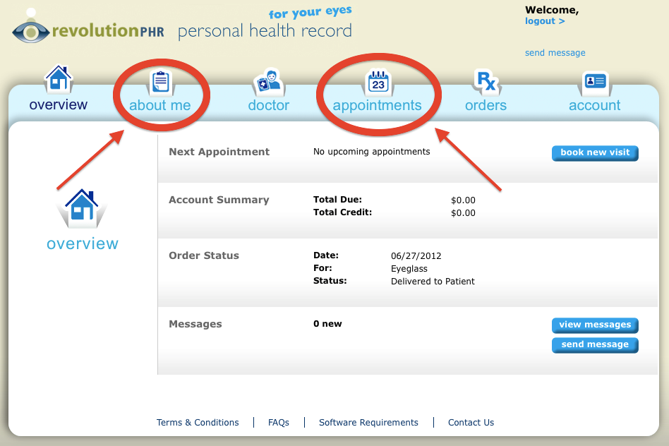

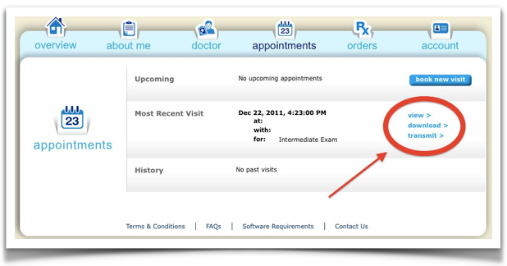
2) Click on “View” to view an online summary or “Download” to download a copy to your computer:

